# OLYMPICS ANALYSIS

**REPORT**

**SUBMITTED IN PARTIAL FULFILMENT OF THE REQUIREMENTS FOR**

**MINOR PROJECT**

# Duration

# (from 2023 to 2026)

**SUBMITTED BY**

**Name: - Mohammad Asif**

**Branch: - Diploma In CSE**

**Roll No: - 537/23**

**Univ. Roll No: -230409504250**



**Department Of Computer Science & Engineering**

**Mehr Chand Polytechnic College**

**Jalandhar, India**

# 

# Abstract

# The Olympic Games serve as a global platform reflecting athletic excellence, international collaboration, and socio-economic trends. This project focuses on analysing historical and modern Olympic data to uncover patterns in athlete performance, country-wise medal tallies, gender participation, and the evolution of sports over time. Using publicly available datasets, the study compares different Olympic years to identify key trends, dominant nations, and emerging sports. Data analysis and visualization tools were applied to extract insights and present them in an understandable format. The project also integrates anomaly detection techniques and real-time data dashboards to highlight unusual events, such as sudden medal spikes or changes in gender representation. This comprehensive analysis aims to provide a deeper understanding of the Olympics’ progression and its broader impact on global sports culture.

**Acknowledgments**

First of all our profound honour goes to our college who has provided all that was needed to complete

this project. Then we wish to express our sincere gratitude to our supervisors “**Mr prince Madan sir”**

for their enthusiasm, patience, insightful comments, helpful information, practical advice and unceasing ideas that have helped me tremendously at all times in my research and writing of this thesis. Their immense knowledge, profound experience and professional expertise has enabled me to complete this report successfully. Without Their support and guidance,

We would also like to express our appreciation for the faculty members of the Computer Sciences

Department of MEHR CHAND POLYTECHNIC COLLEGE for their collaboration and timely support.



**O7 Services** is an ISO 9001:2015 certified company, established in 2015, with a strong reputation for delivering end-to-end IT solutions. The company specializes in a wide range of services, including Web Development, Mobile Application Development, Custom Software Development, UI/UX Design, Hosting Services, Digital Marketing, Domain Registration across multiple extensions, AMC & MMC services, Bulk SMS, and Voice Call solutions.

With 10+ years of experience, O7 Services provides complete business solutions—from consulting and development to deployment, QA, and 24/7 support. Known for timely delivery and affordable pricing, the company builds strong, long-term partnerships. It is based in Jalandhar with a branch in Hoshiarpur.

O7 Services has developed a wide range of software products, including Vehicle Tracking Systems, Invoice Software, School and Hospital Management Systems, Parent-Teacher Communication Apps, Fee and Task Management Systems, Online Food Ordering Applications, Security Apps, Admission Systems, Inventory Software, and Car Servicing Apps. Each solution is designed to be practical, reliable, and user-friendly, addressing real-world business needs effectively.

O7 Services also offers industry-focused training programs, including 6-week and 6-month industrial training, project-based training, corporate training, and job-oriented courses, all tailored to meet current industry needs. The training covers a broad spectrum of modern technologies, such as Full Stack Development (MEAN/MERN), Flutter, Kotlin Android, Swift UI (iOS), Firebase, Python, Angular, React.js, Vue.js, Node.js, ASP.NET, .NET Core, PHP, Laravel, CodeIgniter, Software Testing, Cloud Computing, Blockchain, DevOps, Data Science, Graphic Designing, Artificial Intelligence, Machine Learning, UI/UX Design, Digital Marketing, WordPress, Linux, CCNP, CCNA Security, Network Security, Cyber Security, Ethical Hacking, MCSE, MCITP, Java, Spring, Hibernate, C/C++, Photoshop, Adobe Illustrator, Figma, CorelDRAW, AI Bot and more.

+91- 8437365007, +91-181-5015007

[enquiry@o7services.com](mailto:enquiry@o7services.com) , [hr@o7services.com](mailto:hr@o7services.com) 

[www.o7services.com](http://www.o7services.com)







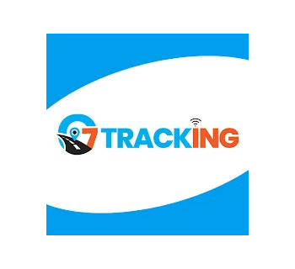

   



   

   

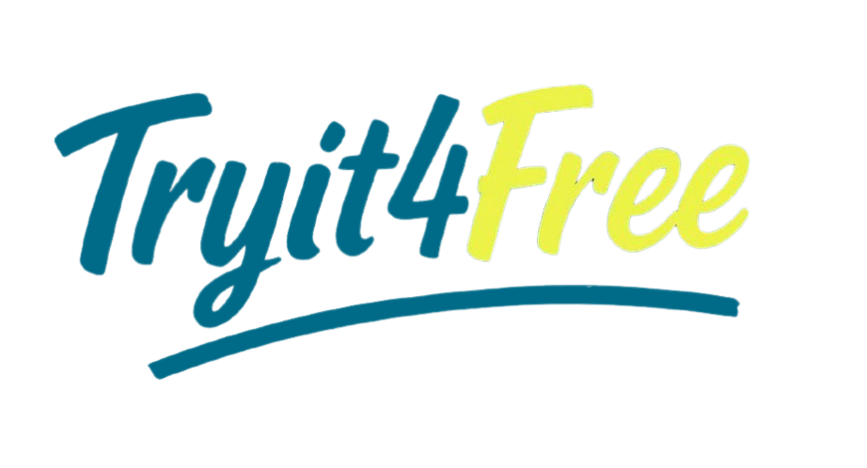   

**CHAPTER 1: INTRODUCTION**

**1.1 INTRODUCTION:**

The Olympic Games are one of the world’s most prestigious and celebrated international sporting events, held every four years with participation from countries across the globe. They represent not just athletic excellence, but also unity, diversity, and the human spirit of competition. Over the years, the Olympics have grown significantly in terms of the number of sports, athletes, nations, and global viewers. With every edition of the Games, a vast amount of data is generated—ranging from medal counts, athlete performances, and country-wise rankings to gender participation, event popularity, and historical trends.

This project focuses on the analysis of Olympic Games data to uncover interesting patterns, trends, and insights that are often hidden within the large volumes of historical information. By analysing this data, we can understand how different nations have performed over time, which sports have gained or lost popularity, how the participation of men and women has evolved, and which countries have shown consistent growth or decline in their Olympic success.

The aim of this analysis is not just to display statistics, but to gain meaningful knowledge from the data. For example, how did global events such as World Wars or pandemics like COVID-19 affect the Olympics? Which countries dominate certain sports, and why? How has the performance of India or other developing nations changed over the years? All these questions can be explored by properly studying and visualizing Olympic data.

This study uses publicly available datasets collected from trusted sources such as the International Olympic Committee (IOC), sports reference websites, and open data repositories. Using tools such as Python, data visualization libraries, and statistical methods, the data is cleaned, processed, and analysed to find patterns and key highlights. Visual graphs, charts, and comparisons make it easier to interpret large data points and present them in a meaningful and simple way.

Another interesting aspect of this project is the chance to explore gender equality and inclusion insports. Earlier Olympics had very low female participation, but that has improved drastically in recent years. We analyse how gender representation has evolved across decades, which countries promote women's sports, and which sports have the most balanced participation today.

This data-driven approach helps not only in understanding past performance but also in making predictions and strategies for future events. Sports authorities, governments, coaches, and analysts can use such studies to focus on training, talent identification, and policy planning. It also helps sports fans and researchers understand global trends and appreciate the evolution of international sports.

In short, this project is all about studying the Olympics through the lens of data—looking at who won, who participated, how the trends changed, and what the future might hold. By analysing real data from past Olympic Games, we can discover valuable insights, celebrate achievements, and prepare better for upcoming events. The main goal is to turn complex information into useful knowledge that contributes to sports analytics and global understanding.

**1.2 PROBLEM DEFINITION**

The Olympic Games generate a large amount of historical data every four years, including athlete performances, country-wise medal tallies, gender participation, event statistics, and more. However, this data is often spread across multiple sources and presented in a raw or unorganized format, making it difficult to analyze or understand the key insights without proper processing.

Most people see the final medal table or top athlete highlights, but few explore the underlying patterns, such as which countries are improving over time, which sports are growing in popularity, or how gender equality has progressed in sports. Also, there is limited awareness of how external factors like world wars, host countries, or political changes affect Olympic results and participation.

Another issue is that developing nations, including India, often underperform in terms of medals despite having a large population. Without data analysis, it’s hard to identify areas where they lag—such as investment in training, lack of participation in certain events, or gender imbalance. These are important questions that can only be answered by deeply studying historical Olympic data.

Therefore, the problem is not the lack of data, but the lack of effective analysis and interpretation of the available data. This project addresses that gap by collecting, cleaning, and analyzing Olympic data using modern tools to reveal trends, problems, and opportunities.

In summary, the main problem is:

* Olympic data is available but not easily understandable without analysis.
* Key insights related to country performance, gender balance, or sports trends are hidden.
* Without proper visualization and study, opportunities for improvement are missed.
* There is a need for a system that turns complex Olympic data into meaningful information for athletes, coaches, policymakers, and sports fans.

**1.3 OBJECTIVES**

The main objective of this project is to perform a comprehensive analysis of Olympic Games data to gain useful insights and support data-driven understanding of global sports trends. The following are the specific goals:

1. Historical Performance Analysis:
   * Analyze the overall performance of countries over different Olympic years.
   * Identify trends in medal tallies and rank changes over time.
2. Country-wise Comparison:
   * Compare developed and developing nations in terms of total medals, sports participation, and athlete count.
   * Track India's performance and compare it with similar-sized countries.
3. Sport-wise Medal Distribution:
   * Identify which sports have the most medals and which countries dominate each sport.
   * Analyze popularity and performance trends of specific events over time.
4. Gender Participation Trends:
   * Study how male and female participation has changed over the years.
   * Identify which countries and sports have balanced gender representation.
5. Impact of Global Events:
   * Observe how global crises (wars, pandemics, economic recessions) influenced the Olympics.
   * Track missing years, boycotts, and performance shifts due to such events.
6. Visualization of Key Metrics:
   * Use charts and graphs to make the data easy to understand for all users.
   * Provide dashboards or reports that show medal counts, participation, and rankings.
7. Prediction and Insights:
   * Based on past trends, try to estimate future performance or growth in specific sports.
   * Offer suggestions for countries to improve their Olympic strategy.
8. Promoting Data Literacy in Sports:
   * Encourage the use of data analytics in sports decision-making.
   * Create awareness about how data can help improve performance and planning.
9. Simple User-Friendly Format:
   * Present data insights in a clear and understandable way.
   * Ensure the findings are accessible to not only analysts but also students, sports fans, and general readers.
10. Support for Policy & Strategy:

* Help government and sports authorities identify strengths and weaknesses.
* Offer data-driven suggestions for funding, training, and athlete development programs.

# CHAPTER 2

# INTRODUCTION TO LANGUAGES, IDE, TOOL AND

# TECHNOLOGIES USED

**1. PYTHON**

Python is a widely used high-level, general-purpose, interpreted, dynamic programming language. Its design philosophy emphasizes code readability, and its syntax allows programmers to express concepts in fewer lines of code than would be possible in languages such as C++ or Java. The language provides constructs intended to enable clear programs on both a small and large scale.

* Python supports multiple programming paradigms, including object-oriented, imperative and functional programming or procedural styles. It features a dynamic type system
* m and automatic memory management and has a large and comprehensive standard library. Python interpreters are available for installation on many operating systems, allowing Python code execution on a wide variety of systems.
* Itis a general-purpose coding language—which means that, unlike HTML, CSS, and JavaScript, it can be used for other types of programming and software development besides web development.

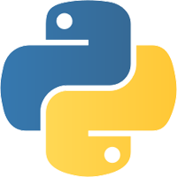

**1.1. Python can be used for things like:**

* Back end (or server-side) web and mobile app development
* Desktop app and software development
* Processing big data and performing mathematical computations
* Writing system scripts (creating instructions that tell a computer system to “do” something)

## 1.2. Why it was called Python

The language’s name isn’t about snakes, but about the popular British comedy troupe Monty Python (from the 1970s). Guido himself is a big fan of Monty Python’s Flying Circus. Being in a rather irreverent mood, he named the project ‘Python’

**1.3. Key Features of Python**

## • Open Source with a Strong Community

Python is an open-source language, which means it is free to use and distribute, even for commercial purposes. This open nature has helped in building a strong community around Python. Developers from around the world contribute to the improvement of the language and its expansive ecosystem of libraries and frameworks.

## • Extensive Libraries and Frameworks

Python’s standard library is very extensive, offering modules and functions for a wide range of tasks. In addition to the standard library, Python’s ecosystem has a vast range of third-party modules. These libraries can help you do everything from sending HTTP requests, to manipulating images, to performing complex data analysis.

## • Compatibility and Integration

Python works on different platforms, meaning it can be used on Windows, macOS, Linux, and even Raspberry Pi. It can easily integrate with other parts of your software stack. Furthermore, Python’s interpretable nature makes it possible to use Python alongside other languages in a larger project

## • Large Community Support

Python has gained popularity over the years. Our questions are constantly answered by the enormous Stack Overflow community. These websites have already provided answers to many questions about Python, so Python users can consult them as needed.

• **Cross-Platform:**

It is a cross-platform programming language, so you can use it on any operating system, including Windows, Linux, Mac, and many more.

### 1.4. Conclusion

Python is a smart and adaptable programming language that has become popular in recent years.

It's easy-to-learn syntax, vast library of functions, modules, and libraries, and support for various programming paradigms make it a perfect choice for a wide array of applications.

From data science to web development, machine learning to automation, Python can be used for almost any task you can imagine.

Learning Python can open up a whole new world of possibilities for aspiring programmers, offering a range of opportunities to build applications that solve real-world problems.

With its vast community of developers, rich ecosystem of libraries and tools, and wide range of applications, Python is a language that's here to stay.

Whether you're just starting out or are an experienced programmer, Python offers a wealth of features and functionalities that can help you build better, more efficient, and more robust applications.

With its ease of use, readability, and broad applicability, Python is a language that every programmer should know.

## 2. DATA SCIENCE

Data science is the analysis of data to find meaningful insights that can be used to inform business decisions. For example, a marketing analyst can use customer transaction data to determine which products customers in one demographic or geographic region buy often and adjust marketing campaigns to target those findings.

Data science is an interdisciplinary field that relies on statistics, scientific computing, algorithms, programming, AI, machine learning, and scientific methods. Because the study and analysis of data are so broad, careers in data science vary greatly. For example, some positions focus on data storage and maintenance, while others are more closely related to journalism, reporting findings from data analysis.

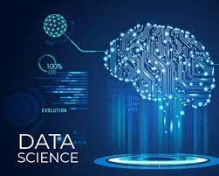

**2.2 Why Data Science Matters**

Ultimately, the primary goal of data science is to help companies make data-driven decisions. Data is ever-growing, and companies need ways to understand their market and customer bases more accurately. As such, the role of data science in business is growing. For example, according to the U.S. Bureau of Labor Statistics, the employment of data scientists is projected to grow 36% from 2021 to 2031.

Some key ways businesses use data science are:

* **Optimization:** Data science allows companies to optimize processes to adapt to changes faster and quickly determine areas of the business that need improvement or are not working as efficiently as they could. Companies also use findings to optimize profitability and marketing campaigns.
* **Innovation:** Data science can help companies craft novel approaches to problems and create new and better business processes.
* **Discovery:** With the help of data science, companies can discover new markets or gaps in product offerings. Data science can also highlight previously unknown problems or redundancies, making companies more efficient.
* **Prevention:** By tracking trends and patterns, companies can avoid future problems. Companies use clean and accurate data to prevent minor issues from growing into ruinous dilemmas. Additionally, data science equips businesses with the tools to adapt to changes quickly and potentially prevent obstacles down the road.

**2.3 Types of Careers in Data Science**

* **Data Scientist**

Data scientists are analytics specialists who analyze and interpret vast amounts of data to find business solutions.

A data scientist is also “an expert in problem-solving and can break down business problems into granular tasks that can be solved using various data science techniques.” says Dushyant Sengar, director of data science at BDO USA.

Some data science techniques include creating statistical models, using software engineering to automate tasks, and working with engineers and business leaders to align company data needs.

* + **Data Analyst**

Similar to data scientists, analysts interpret data to find meaningful insights. However, a data analyst is likely earlier in their career than a data scientist and focuses more on strictly analyzing and reporting. Learn more about the difference between data analysts and data scientists.

* + **Machine Learning Software Engineer**

Machine learning software engineers design, build, and maintain AI systems used to improve the effectiveness of data analysis. Often, this role involves creating models to train the AI programs and testing the quality of outcomes.

* + **Marketing Analyst**

Marketing analysts apply findings from data analysis to marketing decisions. A marketing analyst is responsible for figuring out which products specific markets prefer and tracking the efficacy of different marketing campaigns.

Some marketing analysts work in a specific section of a marketing team. For example, digital marketing analysts focus entirely on online marketing efforts.

**Data Science Tools**

Data Science Tools help implement various steps involved in a Data Science project, such as Data Analysis, Data Collection from databases and websites, Machine Learning model development, communication results by building dashboards for reporting, etc. The most popular tools used in Data Science include -

**Python**

* Python is the most popular and widely used programming language among Data Scientists. One of the main reasons for Python’s popularity in the Data Science community is because of its ease of use and simplified syntax, which makes it easy to learn and adapt for people having no engineering background. The most popular Python libraries used in Data Science are Pandas**,** NumPy**,** SciPy**,** matplotlib**,** Seaborn**,** Scikit-learn**,**, etc.

**R**

* After Python, R is the second most popular programming language used in the Data Science community. It was initially developed to solve the statistical problem but has now evolved into a complete Data Science ecosystem. A few of the most popular R libraries are ggplot2**,** dpylr**,** readr**,** etc.

**SQL**

* SQL stands for Structured Query Language that is used by Data Science professionals to query, update, and manage relational databases and extract data.

**3. DATA ANALYST**

The Data Analyst turns data into insights that companies can use to enhance their decision making processes. Have you ever wondered how big organizations determine which products to create next or how to enhance their services for the future? Well, it's all thanks, to data analysts who go through the data and extract information that benefits the company.

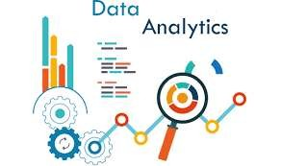

**3.1 What is Data Analytics?**

The process of extracting knowledge from data to support more informed business decisions is known as data analysis. There are normally five iterative stages involved in data analysis:

* + **Stage 1**: Identify the data you wish to analyze.
  + **Stage 2**: Collect the data.
  + **Stage 3**: Prepare the data for analysis, and clean it up.
  + **Stage 4**: Examine the information.
  + **Stage 5**: Interpret the analysis's findings.

**3.2 What are the responsibilities of a Data Analyst?**

A person who gathers and assesses information to tackle a problem is referred to as a data analyst. Besides working with data this occupation also involves communicating discoveries.

Several data analysts perform the following tasks daily:

A. Collect data

* + Analysts frequently assemble data on their own.
  + This can entail carrying out surveys, monitoring the attributes of website visitors, or purchasing data sets from experts in data collection.

B. Clean data

* + Unprocessed data may have mistakes, inconsistencies, or duplicates.
  + To prevent inaccurate or distorted interpretations, cleaning the data entails preserving its quality in a spreadsheet or using a computer language.

C. Model data

* + This comprises building and planning a database's structures.
  + You might decide which data kinds to gather and keep.

D. Analyze data

• Analyzing data entails identifying patterns or trends that will assist you in addressing the current query.

E. 5. Present

• One of the most important aspects of your work will be sharing the findings with others. • You compose reports, make visual representations like graphs and charts, and give information to interested parties.

F. 6. Analyze data

• Analyzing data entails identifying patterns or trends that will assist you in addressing the current query.

G. 7. Presentation

• One of the most important aspects of your work will be sharing the findings with others. • You compose reports, make visual representations like graphs and charts, and give information to interested parties.

**3.3 Conclusion**

The demand for data analysts is expected to rise offering career prospects with competitive pay and diverse opportunities in various fields. By investing in education acquiring certifications and gaining experience individuals aspiring to become data analysts can position themselves for success, in this industry. Also, consider our Data Science with Python Course for a better understanding of data analysis content.

## Library & packages

## I. PANDAS

pandas is an open-source library that provides high-performance, easy to use data structures and data analysis tools for Python. The name “pandas” actually comes from the term “panel data”, an economics concept referring to multidimensional structured data sets.

Some of the key data structures in pandas are:

* Series: A one-dimensional labeled array capable of holding data of any type.
* DataFrame: A two-dimensional tabular data structure with labeled columns and rows. Similar to a SQL table or Excel spreadsheet.

On top of these structures, pandas provides a host of data manipulation and analysis methods that make working with labeled, structured data fast, efficient, and intuitive in Python.

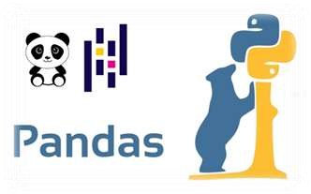

**Why Use pandas?**

pandas offers Python programmers an extremely intuitive and feature-rich interface for working with labeled, tabular data. Here are some of the key reasons pandas is a go-to tool for data analysis in Python:

* **Fast and efficient:** Operations like aggregations and groupby are optimized to provide high performance on large data sets.
* **Powerful data structures:** The DataFrame and Series objects allow intuitive access to data and metadata.
* **Intuitive syntax:** Operations like merging, reshaping, slicing, selecting, and transforming data sets mirror conventions from other coding languages and domains.
* **Built-in visualization:** Integration with Matplotlib makes plotting and visualizing data sets quick and easy.
* **Handy data manipulation:** Methods like drop(), fillna(), pivot(), and groupby() provide easy ways to wrangle messy data sets.
* **Interoperability:** pandas integrates nicely with other core Python data science libraries like NumPy and scikit-learn.

In short, pandas combines the high performance and flexibility of NumPy with the easy to use and intuition of spreadsheet programs like Excel. This makes interactive data analysis and munging in Python a productive and enjoyable experience.

## II. NUMPY

NumPy is a Python library that provides support for large, multi-dimensional arrays and matrices, along with a large collection of high-level mathematical functions to operate on these arrays. With a reputation for high performance, it is often used for scientific computing tasks, such as:

* Mathematical operations like linear algebra, Fourier transform, and random number capabilities.
* Tools for integrating C/C++ code.
* Extensive capability to process large multidimensional arrays and matrices.

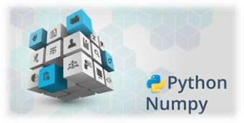

**Why use NumPy?**

* As a data scientist, you will be dealing with large datasets that contains thousands of rows and columns.
* Using the traditional Python lists makes data preprocessing and analysis slower, especially because lists take up more memory space. Also, working with lists can quickly become lengthy and tiresome because of the many lines of code required to achieve a particular result.
* NumPy is able to achieve all these because of arrays. Arrays reduce the overall size of the code, and because each array contains data of the same type, this speeds up computations and makes it easier to store and manipulate large amounts of data.

## III. Matplotlib

Matplotlib is a low-level or 2-dimensional plotting Python library that helps in data visualization. It is an open-source and free library created by John Hunter.

Matplotlib is a multi-platform library built on NumPy arrays and designed to work with the broader SciPy stack. It is mostly written in python with a few segments written in C, ObjectiveC, and Javascript for Platform compatibility. It can be used in different graphical user interface toolkits such as python scripts, shell, web application servers, etc.

Pyplot is a module in the Matplotlib module which provides a MATLAB-like interface. With this, we can build line plots, histograms, bar charts, scatter plots, etc. In addition, we can also set the features for these plots which include labels, font properties, axes properties, line styles, etc.

## Here is the different methods to visualize the data using matplotlib =>

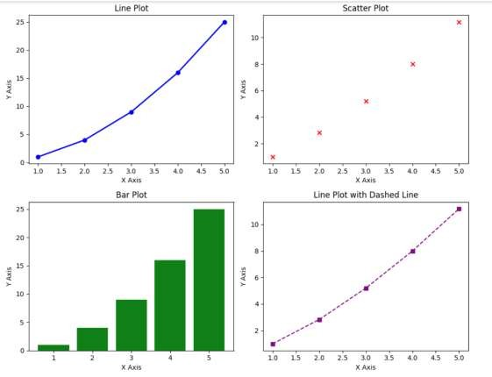

*Figure 7*

## IV. SEABORN



Seaborn is an open source Python library built on top of a matplotlib. Used for data viewing and analysis of test data. Seaborn easily works with data frames and the Pandas library. Created graphs can also be customized easily. Below are a few of the Data Identification Benefits.

* Graphs can help us find useful data trends for any machine learning or prediction project.
* Graphs make it easy to present your data to non-technical people.
* Attractive graphs can make presentations and reports more appealing to the reader.
* Seaborn is an amazing data visualization library for editing mathematical graphics in Python. Provides beautiful automated styles and color palettes to make mathematical pieces more attractive. Built on top of the matplotlib library and reassembled near data structures from pandas. In this tutorial, we will look at how to use seaborn to make a variety of sites and how to use them and matplotlib to make our sites more attractive.

**Features of Seaborn:**

Seaborn is made on the Python core library Matplotlib. it’s supposed to function as a complement, not a substitute. However, Seaborn comes with some vital options. Let’s have a look at many of them here. options facilitate –

* Designed with themes to vogue matplotlib graphics.
* Visualize static and quantity information.
* Installation and visual image of retrospective models.
* Rich information statistic statistics.
* Seaborn works well with NumPy and Pandas information structures.
* Comes with intrinsic themes for Matplotlib vogue drawings.
* In most cases, you’ll still use Matplotlib to form an easy plot. Matplotlib info is usually recommended to mend Seaborn default sites.

## V. PLOTLY EXPRESS

As a data scientist or analyst, you have likely used Matplotlib for visualizing data, but if you are looking for a more interactive, flexible, and user friendly tool, Plotly Express is a game changer. Whether you are analyzing data, presenting insights, or creating dashboards. Plotly Express gives you a simpler way to build interactive visualizations without the hassle of extensive coding.

-> Why Plotly Express for Data Scientists?

Here’s why Plotly Express is ideal for data science:

* Fast Prototyping: You can create high-quality plots in just a few lines of code, allowing you to focus more on analysis and less on the nitty-gritty of plot design.
* Interactivity: Built-in interactivity is great for exploratory data analysis (EDA) and communicating insights with non-technical stakeholders.
* Web Compatibility: Perfect for embedding visualizations in web apps or sharing reports via dashboards.

Here are different visuals if you see data with plotly express =>

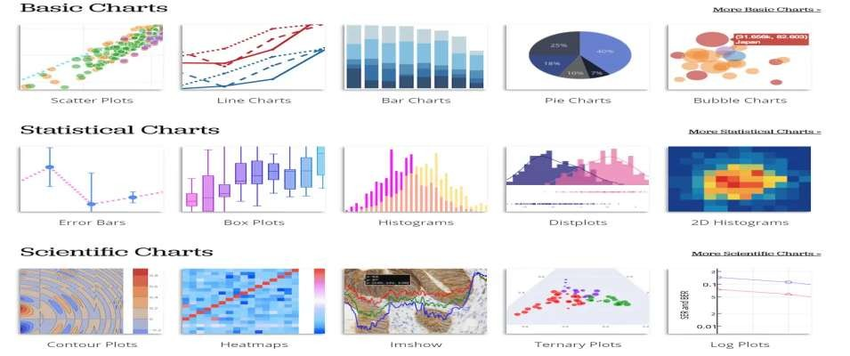

*Figure 8*

**4. TOOLS AND EDITORS**

**I. IDLE**

*Figure 9*

Python IDLE (Integrated Development and Learning Environment) is an integrated development environment for Python that comes bundled with the standard Python distribution.

It serves as a convenient tool for writing, testing, and debugging Python code.

Python IDLE provides a graphical user interface (GUI) that simplifies the coding process and helps users manage their Python projects efficiently.

Python's IDLE capability enables programmers to write and execute a single line of code, much as how Shell writes and edits code.

It is extremely user-friendly, especially for novices, due to features like intelligent indentation and highlighting. This and many other aspects make Python one of the preferred choices for beginners to progress in their programming journey.

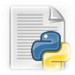

**IDLE features:**

* Cross Platform : Works on Unix and Windows.
* Multi-window text editor with syntax highlighting and smart indent and other.
* Python shell window with syntax highlighting.

GUI OF IDLE=>

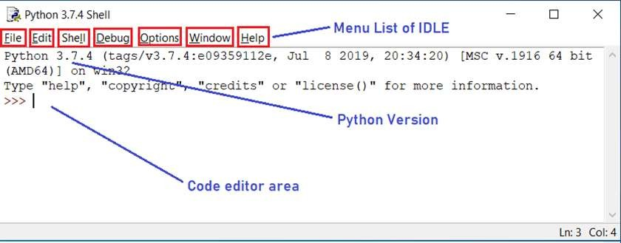

*figure9. 1*

**II. VISUAL STUDIO CODE ( VS CODE )**

Visual Studio Code, affectionately known as VS Code, is a free tool created by Microsoft that helps you write and manage code.

Think of it as a sophisticated text editor, like Microsoft Word, but instead of formatting letters and reports, it's designed to help you write and organize computer code for websites, apps, and software.



**Key Features of VS Code That Make Coding Accessible**

* **Extensions for Everything:** Just like adding apps to a smartphone to increase its functionality, VS Code allows you to install extensions to support different languages (like HTML for websites, Python for data science, or JavaScript for web applications) and tools to make coding easier and more efficient.
* **Guided Code Writing:** VS Code comes with something called IntelliSense, which is like having a helpful assistant that suggests how to complete your lines of code, identifies typos, and even explains what certain commands do. This feature is incredibly beneficial for beginners learning the ropes.
* **Integrated Git Support:** Imagine writing a long document and wanting to save different versions as you make significant changes. Git is a system that lets you do this with code. VS Code has built-in Git support, making it easier to track changes, save different versions of your project, and collaborate with others.
* **Debugging Tools:** Debugging is the process of finding and fixing errors in your code. VS Code has built-in tools to help you identify where things went wrong, allowing you to solve problems without leaving the app.
* **Personalize Your Workspace:** With customizable themes, icons, and shortcuts, VS Code lets you create a coding environment that feels comfortable and personal, making the learning process more enjoyable.

**Limitations of Visual Studio Code (VS Code)**

VS Code feels like a godsend after reading Visual Studios limitations, right? But hold your horses, for this software has its limitations too.

* **Less Integrated:** VS Code doesn’t come with many integrated dev tools. While this makes it lightweight, it also means that significant setup via extensions is often necessary to match the functionality of a full IDE. It also requires manual setup for compilers, debuggers, and language-specific features.
* **Extension Reliance:** The need for extensions for even basic functionalities like syntax highlighting, debugging, etc, can lead to dependency issues or conflicts between extensions. This can sometimes result in an inconsistent development environment or require time spent managing extensions.
* **Performance with Extensions:** While VS Code is inherently fast and efficient, loading it with numerous extensions can bog down its performance, making it less snappy than it is intended to be.
* **Comparatively Less Advanced Debugging:** VS Code’s debugging tools, though robust, are not as advanced or seamless as those found in a full IDE like Visual Studio. For complex applications, particularly large enterprise levels, this might be a constraint.
* **Less ideal for C# centric Applications:** Compare to Visual Studio setting up VS Code to work with C# can be a hassle and would still lack some functionalities provided by Visual Studio.

# JUPITER NOTEBOOK

When you think of a notebook, you probably imagine a collection of blank pages that you can use to write down your thoughts or make notes. What if we told you that notebooks aren't limited to paper? What if a new kind of notebook lets you do everything and more? That's right: the Jupyter Notebook!

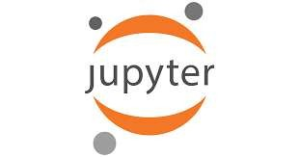

The Jupyter Notebook is a Python-based user interface where users can work with an ordered list of input/output cells to achieve Python Web server-related tasks and deposit code solutions. Users can also run code cells in parallel, view the results of their work as they type it in, and interact with other users via messaging systems built into the application.

Jupyter Notebooks are a popular tool for data scientists and those who like to do some statistics on the side. The notebooks allow users to write their code in one place, then send it off to the Jupyter kernel, which interprets the code and displays the results. Additionally, users can also set up different kernels for different languages.

Users can use this feature to write their code in R, Python, Julia, or other popular programming languages and see how it will react before they run it live on their computer. So what makes this new kind of notebook so special? It's simple: it allows people to do more than ever before— and it makes learning more accessible than ever before too!

# GOOGLE COLLAB

Google Colab is a Jupyter Notebook-like product from Google Research. A Python program developer can use this notebook to write and execute Python program codes just using a web browser.

In a nutshell, Google Colab is a cloud-hosted version of Jupyter Notebook. To use Colab, you do not need to install and runtime or upgrade your computer hardware to meet Python’s CPU/GPU intensive workload requirements.

Colab gives you free access to computing infrastructure like storage, memory, processing capacity, graphics processing units (GPUs), and tensor processing units (TPUs).

Google has specially programmed this cloud-based Python coding tool, keeping in mind the needs of machine learning programmers, big data analysts, data scientists, AI researchers, and Python learners.

The best part is one code notebook for all the components needed to present a complete machine learning or data science project to program supervisors or sponsors. For example, your Colab notebook can contain executable codes, live Python codes, rich text, HTML, LaTeX, images, data visualizations, charts, graphs, tables, and more.



**Google Collab Features**

* Cloud Storage
* GitHub Integration
* Multiple Data Sources
* GPUs and TPUs
* Pre-installed Libraries

# STREAMLIT

Streamlit is a Python-based framework that allows developers to create interactive web applications with minimal effort. It’s particularly useful for data-driven applications, enabling seamless integration with popular libraries like Pandas, NumPy, and Matplotlib. With Streamlit, you can quickly build and share data apps without needing extensive web development experience.

**a) Use Cases of Streamlit**

* **Data Visualization**: Create real-time interactive dashboards.
* **Machine Learning**: Deploy models with interactive UI.
* **Business Analytics**: Build reporting dashboards with data insights.
* **Prototyping**: Rapidly develop and test ideas without web development expertise.
* **Education**: Create interactive learning tools and simulations.
* **Automated Reporting**: Generate auto-updating reports with a user-friendly interface.

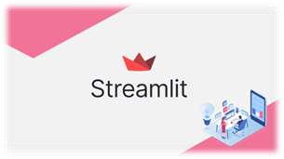

**b) Key Features of Streamlit:**

* **Fast & Simple:** No need for additional web technologies, just Python.
* **Interactive Widgets:** Use sliders, buttons, text inputs, and more for user interaction.
* **Live Code Updates:** The UI auto-refreshes when the script changes.
* **Performance Optimization:** Speed up apps with built-in caching @st.cache_data.
* **Data Visualization Support:** Supports Matplotlib, Plotly, Seaborn, Altair, and more.
* **Easy Deployment:** Deploy instantly via Streamlit Cloud, AWS, GCP, or Azure.
* **API Integration:** Easily integrate with RESTful APIs, databases, and cloud storage.
* **Customization:** Use themes and CSS modifications to enhance the UI.

**Chapter :**

**Summary and Conclusions**

**7.1 Summary**

In conclusion, this project titled "Olympics Data Analysis using Python" focuses on understanding the historical trends and insights of the Olympic Games through data analysis techniques. The Olympics, being a major global event, generates a massive amount of data related to countries, athletes, sports categories, medals, gender participation, and performance across various editions of the Games. By using publicly available datasets, this project analyzed key aspects of the Olympic Games over time.

The data was cleaned, processed, and visualized using Python libraries such as Pandas, Matplotlib, and Seaborn. Through visual representations, we were able to observe significant trends such as the rise of medal counts for some countries, the increase in female participation, and the dominance of specific nations in particular sports. Historical analysis helped show how global events like wars or pandemics caused changes in participation and performance.

The project also focused on India's Olympic journey and how its performance has changed over different editions. Comparisons with other nations highlighted the gap and potential areas of improvement. Additionally, sport-wise analysis helped to identify which events are most competitive and which countries consistently excel in them.

By conducting this analysis, the project not only uncovered meaningful insights but also demonstrated the power of data analytics in the sports domain. It bridges the gap between raw Olympic data and understandable information that can support future planning and strategy for athletes, coaches, and sports authorities.

**7.2 Conclusions**

The project successfully utilized Python to analyze and visualize historical Olympic Games data.  
 Significant trends were identified, including medal growth patterns, country-wise performance, and gender participation shifts.  
 The analysis revealed that developed countries dominate most Olympic sports, but developing nations are gradually improving.  
 Python-based data analysis proved to be an effective and time-saving tool to uncover hidden patterns in large datasets.  
 Insights from the project can be used by sports institutions and policymakers to guide future training and resource allocation.  
 The findings encourage further use of data-driven decision-making in global sporting events.

**7.3 Future Scope**

The current project provides a strong foundation for deeper studies and real-time applications in the field of sports analytics. Some of the possible future enhancements and directions are:

* Advanced Predictive Models: Use machine learning techniques to predict future medal winners, country ranks, or athlete performance based on past data trends, age, country, and sport.
* Real-Time Analytics: Incorporate live data from ongoing or future Olympics to provide real-time dashboards showing medal updates, top-performing nations, and upcoming events.
* Interactive Dashboards: Develop a web-based dashboard using Python frameworks like Plotly Dash or Streamlit to allow users to interact with the data visually.
* AI-based Talent Scouting: Use past Olympic data to build models that can help identify potential athletes from underperforming nations by analyzing age, sports background, and trends.
* Gender Equality Tracking: Create a monitoring system to track the progress of gender balance in sports for each Olympic edition and suggest policies for equal opportunities.
* Support for National Sports Planning: Governments and sports federations can use such data analytics projects to focus on weaker areas, train athletes for specific events, and improve their medal count in upcoming Games.
* Comparative Studies: Expand the dataset to include data from other international sporting events (like Commonwealth Games, Asian Games) for comparative performance analysis.

**Chapter :**

**References And Bibliography**

* **Kaggle Datasets – Global Unemployment**[**https://www.kaggle.com/datasets**](https://www.kaggle.com/datasets)
* **Python Official Documentation**[**https://docs.python.org**](https://docs.python.org)
* **Pandas Documentation**[**https://pandas.pydata.org**](https://pandas.pydata.org)
* **NumPy Documentation**[**https://numpy.org**](https://numpy.org)
* **Matplotlib Documentation**[**https://matplotlib.org**](https://matplotlib.org)
* **Seaborn Documentation**[**https://seaborn.pydata.org**](https://seaborn.pydata.org)
* **Plotly Express Documentation**[**https://plotly.com/python/plotly-express/**](https://plotly.com/python/plotly-express/)
* **Streamlit Documentation**[**https://streamlit.io**](https://streamlit.io)
* **Google Colab**[**https://colab.research.google.com**](https://colab.research.google.com)
* **Visual Studio Code (VS Code)**[**https://code.visualstudio.com**](https://code.visualstudio.com)